Assignment 7

# Objective: Routing using RIP version 2 protocol.

**Solution**: Draw the network diagram as shown in figure below and make the configuration shown under it. Ping PC2 ip address from PC1 to validate the setup.

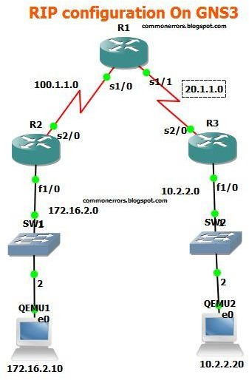

RIP routing protocol have simple configuration, you need a just network command to advertised the connected networks.

# Configuration for R1:

R1#conf t R1(config)#int s1/0

R1(config-if)#ip add 100.1.1.2 255.255.255.0 R1(config-if)#no shut

R1(config-if)#int s1/1

R1(config-if)#ip address 20.1.1.1 255.255.255.0 R1(config-if)#no shut

R1(config-if)#ex

# RIP Configuration Commands for R1:

R1(config)#router rip R1(config-router)#version 2

R1(config-router)#network 20.1.1.0

R1(config-router)#network 100.1.1.0

# Configuration for R2:

R2#config t R2(config)#int f1/0

R2(config-if)#ip address 172.16.2.1 255.255.0.0 R2(config-if)#no shut

R2(config-if)#int s1/0

R2(config-if)#ip address 100.1.1.1 255.255.255.0 R2(config-if)#no shut

R2(config)#router rip R2(config-router)#version 2

R2(config-router)#network 172.16.0.0

R2(config-router)#network 100.1.1.0

# Configuration for R3:

R3(config)#int s2/0

R3(config-if)#ip add 20.1.1.2 255.255.255.0 R3(config-if)#int f1/0

R3(config-if)#ip add 10.2.2.1 255.255.255.0 R3(config-if)#ex

R3(config)#router rip R3(config-router)#ver 2

R3(config-router)#network 10.2.2.0

R3(config-router)#network 20.1.1.0 RIP Verification Commands:

Show ip route command should display all RIP networks and end to end ping should be successful.

